

Monday December 29– No Mass
Tuesday December 30-9:00 a.m.–Michael & Nick Greco
7 p.m. – Margaret Carson, Alfred & Angela Correa, George & Frances Clare Winn, Joanne Brode, Giuseppe Ippolito, In thanksgiving to the Holy Family, Special intentions of Kim, Jerry & Benjamin Britto, Florencio Bernardo
Wednesday December 31- NEW YEARS EVE – 5 p.m
Thursday January 1-MARY MOTHER OF GOD
9:00 a.m. 10:30 a.m. 12 Noon
First Friday January 2– No Mass
First Saturday January 3-9:00 a.m. –For the Prolife movement
5:00 p.m. – Mark Donahoe, In thanksgiving, Domenico, Rosa & Romeo Catalucci, Giuseppe Barone, Margaret Carson, Carmen Murraca, Bernice Columbus, Russell Rice
Sunday January 4
9:00 a.m. – Carlo Fede
10:30 a.m. – Michael Zvonar
12:00 p.m. – Pro Populo

PRAY TO OUR MOTHER OF PERPETUAL HELP

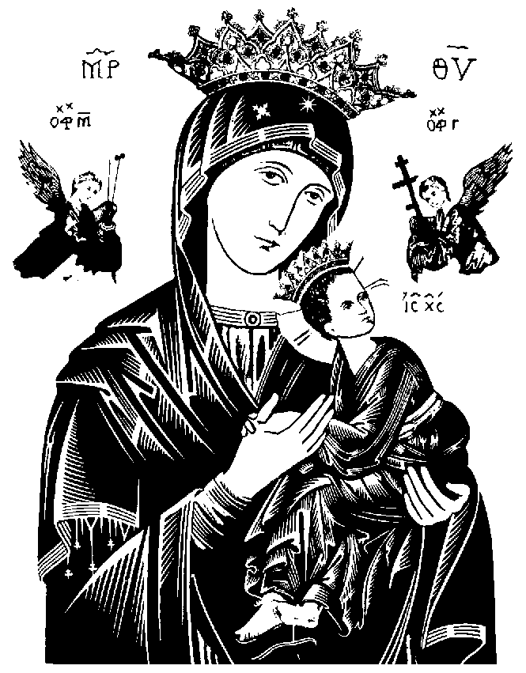
The two blue candles by Our Mother of Perpetual Help can be lit for your intention ($5 each). The shrine is located by our Blessed Tabernacle. We encourage all of our parishioners to take a moment and offer a prayer for these intentions:

Special intentions of Annunciation of Our Lord’s parishioners.

Diocesan Prayer Calendar

Monday: Rev. Marijan Mihokovic
Tuesday: Rev. Charles Galea
Wednesday: Ordo Canonicorum Regularium Sanctae Crucis
Thursday: Rev. Rev. Michael McHugh
Friday: Most Rev. Douglas Crosby, OMI, DD
Saturday: Rev. Aurimas Rudinskas, O.P.

READINGS FOR NEXT SUNDAY


Isaiah 60.1-6
Ephesians 3.2-3a, 5-6
Matthew 2.1-12

“They knelt down and paid him homage”

OFFERINGS


Sunday Offerings

Sunday November 30th $7,280.60

Thank you for your support!

PARISH OFFICE CLOSED

The Parish office will be closed on Wednesday December 31 and Thursday January 1st. We would like to wish everyone a very blessed New Year!

THE INJUSTICE OF HUMAN TRAFFICKING

Learn more about this troubling issue and the dangers posed to youth within our own communities. “Nefarious”, a documentary film, will be presented Wednesday January 14th and Wednesday January 21st, 2015 at 7:00 pm, here at Annunciation of Our Lord Parish Centre. Co-sponsored by the Lay Associates of the Sisters of St. Joseph of Cluny and CWL Hamilton. To register your attendance, please call Linda Pandzich at 289-768-4849 or Maureen Harper at 905-574-5552. Free will offering only in support of survivor services.

KNIGHTS OF COLUMBUS

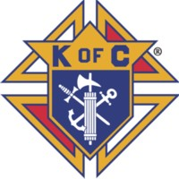
Please support the following Knights initiatives in our parish:
The Knights are selling tickets to the Hamilton Bulldogs Hockey Game against the Rochester Americans on Friday, March 6th, 2015. We have secured a discounted price of $15 for the regular $20 price. For more information please call Tim at 905-575-0767.
Again this year, we are running a Bottle Drive on the first Sunday of the New Year. Please save and drop off holiday empties (wine, liquor, beer bottles and cans) after all three masses on Sunday January 3rd.
The Knights will be running our second Parish/Community Breakfast on the Sunday of Shrove Tuesday week. Mark Sunday February 15 on your calendar. There will definitely be pancakes as well as the other items served at the past breakfast, sausages, bacon, eggs, toast, coffee, juice, etc) Tickets will be available beginning the first Sunday in January.
Men interested in the Knights of Columbus please join us the 3Rd Thursday of each month at 7pm in the Parish Centre.

CATHOLIC WOMEN’S LEAGUE


In January 2015 when placing your membership envelope in the offertory basket, be it from the Sunday Offering box or a plain white envelope, please include your Name on the envelope as our membership chair does not have a list of envelope numbers. Thank you ahead of time for your cooperation. Your President, Daniela.

PARENTING TIP OF THE MONTH

In the Christmas carol O Holy Night we hear these words: “Long lay the world in sin and error pining. Till He appeared and the Soul felt its worth.” The words are a beautiful reminder that we are loved by God and that Christ’s birth reminds us of our inherent value. In a world that can, at times, be hurtful, our children can seek refuge in loving families and through a personal relationship with Jesus. Christmas is a lovely time to remind our children that when Jesus was born he came to live among us and that he still wants to be with each of us today. Through prayer, attending Mass and simply talking to God about the highs and lows of their day, children can develop a friendship with Jesus who loves them deeply. This Christmas, give your children a powerful gift by helping them develop a friendship with our Saviour. –Teresa Hartnett, Family Ministry Office, 905-528-7988 ext. 2250

2015 OFFERTORY ENVELOPES

The 2015 Offertory envelopes are available for pickup in the hall beside our Parish Centre. Please be sure to pick up yours early!

2014 INCOME TAX RECEIPTS

We would like to say thank you to everyone who has financially contributed to support the upkeep & running of our parish during this past year. We truly appreciate ALL donations regardless of the amount. Income tax receipts
will be issued to everyone who gave more than $25.00 for the year. If you gave less than $25.00 for 2014 and desire an income tax receipt please call the parish office and inform the secretary and a receipt will be provided.

CANADA POST

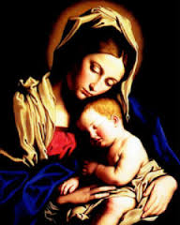
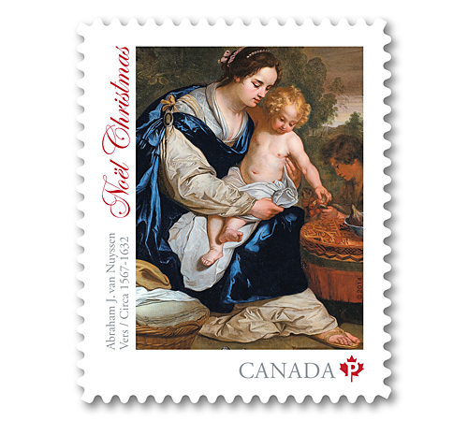
Canada Post has once again printed Christmas stamps with a Christian theme and they are available now. When you are purchasing stamps, please request these special stamps to ensure that Canada Post will continue the practice of printing religious themes on the stamps each year!

WORLD YOUTH DAY 2016 KRAKOW POLAND

Join us July 19-August 2, 2016 as we participate in World Youth Day activities both in Days in the Diocese and in Krakow, Poland! The pilgrimage includes return flight, 14 days in Poland, accommodation, busing and most meals. 5 “Days in the Diocese”, 7 days World Youth Day, 2 days sightseeing. Space is limited so book today!
Participants must be 18-35 years of age at time of travel. Contact David Dayler at the Discipleship & Parish Life Office, ddayler@hamiltondiocese.com or visit our website at www.hamiltondiocese.com, for more information and registration forms.

Annunciation of Our Lord Parish
Youth Ministry

CONQUEST (Boys Club) AND CHALLENGE (Girls Club)

Coming in the New Year!

Place: Annunciation of Our Lord School-250 Limeridge Rd W. Hamilton
Participants: Boys(Conquest) and Girls (Challenge) Grades 4-8 (Mom & Dad are welcome!)
Cost: TBA Annual Membership(Dad or Mom for free)
Dates: Starting in February 2015 (6:00 – 7:30 pm)
These amazing programs will be running twice a month at Annunciation of Our Lord School starting in February 2015. Please do prayerfully consider having your boy or girl attend these programs. They will not regret it!
( For more information... Please contact Mrs Tess Perez @905.388.2078 ext 201)

“Amen, I say to you. Whatever you do to the least brothers of mine, you did it for me”
Matthew 25:40

